
Sreenidhi Institute of Science and Technology
(An Autonomous Institution)
Regulations:
A14
Code No: 4C303 Date:5-Dec-16(FN)
B. TECH. II-Year I-Semester Examinations, Nov/Dec 2016 (Supplementary)
PROBABILITY THEORY AND STOCHASTIC PROCESS (ECE)

Time: 3 Hours Max. Marks: 70
Note: a) No additional answer sheets will be provided.
b) All sub-parts of a question must be answered at one place only, otherwise it will not be valued.
c) Assume any missing data.

Part - A
Max.Marks:20

Answer all QUESTIONS. EACH QUESTION CARRIES 2 MARKS.
- Let A be an arbitrary event, show that 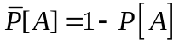
- Is the 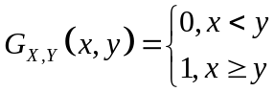 a valid joint distribution function? Justify your answer
- Define random Process.
- Write any two properties of cross correlation function
- Define Mean ergodic process.
- What is thermal noise
- What is power transfer function of the system.
- Define wide sense stationary process
- Out of three events A, B, C if A & C are mutually exclusive and if P(A∩B) = 0.02,
P(C∩B) = 0.03, P(B) = 0.1, Find P[(A ∪C)/B].
- Define joint characteristic function of two random variables.
Part – B
Max.Marks:50

ANSWER ANY FIVE QUESTIONS. EACH QUESTION CARRIES 10 MARKS.

1 (a) In a bolt factory, machines A,B and C manufacture 25%, 35%, 40% of the total. Of their output 5%, 4% and 2% are defective bolts. A bolt is drawn at random and is found to be
defective. What are the probabilities that it was manufactured by
(i) machines A (ii) machines C

(b) In a game of dice, a shooter can win if the sum of the two numbers showing up is either 7 or 11 when two dice are thrown. What is his probability of winning?

2(a) X is a continuous random variable with probability density function
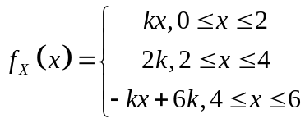
Find the mean value of X..

(b) Two independent random variables X and Y have mean values E(X) =2, E(Y) =4 and their 2nd moments are E(X²)=8, E(Y²) =25. Find
(i) Mean value
(ii) 2nd moment
(iii) Variance
of the random variable W=3X-Y.

3(a) Discuss about various types of random processes with examples
(b) Write the properties of auto correlation function

4(a) If a random process {X(t)} is defined by {X(t)} =sin(Wt+Y)where Y is uniformly distributed in
(0, 2π). Show that {X(t)} is WSS.
(b)Find the power spectrum corresponding to the auto correlation function 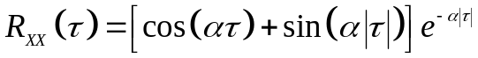 where >0 is constant.

5(a) A random Process 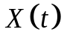 is applied to a linear time invariant system. A response 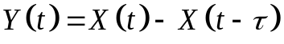 occurs where is real constant. Sketch the block diagram of the system and find the Systems transfer function.

(b) Write short notes on power density spectrum of response.
6. Write short notes on:
(i) Cyclostationary Process
(ii) Shot noise
(iii) band limited Process.

7(a) Determine cross power density spectrum corresponding to the cross correlation function

(b) Explain the spectral characteristics of system response.

8(a) A fair coin is tossed twice. Define random variable by X = Number of heads on the first toss, Y = Number of heads on the second toss. Find and sketch the joint density function of
X and Y

(b) A random variable X is Gaussian with a_{x} = 0 and 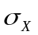 = 1. What is the probability that IXI> 2?

-- 00 -- 00 --

